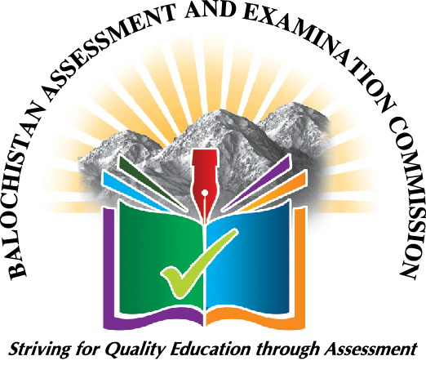 | BALOCHISTAN ASSESSMENT AND EXAMINATION COMMISSION (BAEC)  Application for Selection of Academic Supervisor (Mentor)  Photograph
Instructions:
1. Form must be filled in Capital letters.
2. Attach one attested photographs.
3. The form must be submitted to District Education Officer till 10th May, 2023.
4. The District Education Officer must verify the form after checking applicant’s credentials.

Name of Teacher. (Urdu) ________________________ (English)_______________________________________
Father’s Name. (Urdu) ___________________________(English)_______________________________________
Date of Birth ________________________ CNIC No. ______________________________________
Date of Appointment ______________________ Designation. ________________Grade (BPS)_________
Academic Qualification. _________________ Professional Qualification _______________________________
Name of School _______________________________________________________________________________
Name of Cluster ______________________________________________________________________________
Total Teaching Experience in years______________ in primary level__________ in middle level __________
Applying subject: _____________________________ Level of _______________________________________
Mobile No. of Teacher___________________________ Residence Phone No.______________________
Union Council__________________ Tehsil_______________________ District ____________________
Postal Address of Teacher._____________________________________________________________
School BEMIS/EMIS Code:__________________________________

School Location:- Urban Rural

School Gender: Male Female Co-education

Medium of Instruction : Urdu English
School Principal/Head Master/Head Mistress Name: ______________________________________
Mobile No. _____________________________ Office No. _________________________________

Signature of the Teacher ___________  Date: _______________ |  | Signature of Principal/Head Master/Head Mistress/DDEO/DOE  Stamp__________________  Date: __________________________  Mobile No: _________________________

Signature of District Education Officer
Stamp__________________
Date: __________________________
Mobile No: ____________________________

